

Site Build Monitoring &
Tracking Application
User Requirement Specifications
Provided by:  Damco Solutions Inc. |  | Contact Person:  Pankhuri Gupta |  |  |  | Email: pankhurig@damcogroup.com
 |  |  |  |  |  |  | 
101 Morgan Lane,  Suite # 205,  Plainsboro NJ 08536 | +1 609 632 0350 |  |  |  | +1 888 853 7859 |  | www.damcogroup.com

DOCUMENT HISTORY
Date | Version | Document Revision Description | Document Author
June 20, 2025 | 1.0 | Initial Draft – Work in Progress | Pankhuri Gupta
June 27, 2025 | 1.1 | Updated – API tables | Pankhuri Gupta
July,07,2025 | 1.2 | Updated - flow diagram, Milestone list for build out phase – Connected Utility;  Critical environment | Pankhuri Gupta
July, 29,2025 | 1.3 | mails specifications, manual steps inclusion | Pankhuri Gupta
July, 30,2025 | 1.3 | Wireframes Updates, Flowchart modifications | Pankhuri Gupta
August 06,2025 | 1.4 | Included Finance Approval steps, Updated the project phases titles and the UX diagrams snippets | Pankhuri Gupta
August 21, 2025 | 1.5 | Updated Milestones for Planning & Approval Phase of project | Pankhuri Gupta
September 15, 2025 | 1.6 | Updated capex form points & finance approval process | Pankhuri Gupta
September 18, 2025 | 1.7 | Updated milestones in project initiation phase;  re-arrange the sourcing milestones in planning & approval phase | Pankhuri Gupta

APPROVALS
Date | Version | Approver Role | Approver

Contents

1. INTRODUCTION 4
2. SCOPE 4
3. Design overview 5
3.1. purpose 5
3.2. Technologies used 5
3.3. AS IS PROCESS 6
3.4. TO BE PROCESS 7
4. SUMMARY OF DATA REQUIRED VIA API……………………………………………………………………………………………………………………………..24
5. KEY ASSUMPTION 26

INTRODUCTION
Alorica is a global leader in customer experience (CX) solutions, providing outsourced customer service and support across various industries.
Headquartered in Irvine, California, Alorica operates in over 18 countries with a strong presence in the Americas, EMEA, and APAC. The company focuses on digital transformation, automation, and delivering personalized customer interactions through voice, chat, and back-office support.

Alorica reached Damco to help in automating the tracking & monitoring of the Site Build Process across the organization.

SCOPE
This solution supports tracking and managing site build activities across different functional departments including PMO, IT, Facilities, and Finance. It enables centralized status monitoring, SLA tracking, and milestone forecasting while integrating with existing enterprise systems at Alorica.
In Scope:
- CAPEX request form
- Seamless integration with ServiceNow & EDL (Oracle) through REST APIs
- Auto-triggered mails throughout the process for capex forms and milestones status
- Executive dashboard of project’s Kanban
- Milestone tracking dashboard
- SLA & TAT monitoring of milestones
- Data transfer from OutSystems to Alorica’s Power App
(*We will develop an API to expose the required data, which the Power Apps team can then consume for updating data on their end. The PRJ Number can serve as the unique identifier)

Out of Scope:
- Data updates from OutSystems to Oracle/EDL or ServiceNow
- Data accessibility from any other sources (Except Oracle & ServiceNow)

Design overview

purpose
The solution should aim to unify multiple applications within a single interface, offering users a smooth and cohesive experience. This approach will enable easy access to essential information without the need to switch between different systems. Furthermore, where required, data will be synchronized to the platform in near real-time, ensuring updates are captured and reflected quickly

Technologies used
This application primarily uses the following technologies:

ID | Application Name | Details
1 | Out Systems Platform | Version 11.35.0
2 | Azure AD | Access to be received & checked
3 | EDL (Oracle) | TBD - API details will be attached once shared by Alorica
4 | ServiceNow | TBD - API details will be attached once shared by Alorica
5 | MS-Outlook | SMTP details to be received
6 | SIEM | IBM Qroc

AS IS PROCESS

Currently, Alorica's site build tracking process is largely manual and fragmented, relying on multiple disconnected tools such as Oracle (for Capex and procurement), ServiceNow (for PMO and IT activities), PowerApps Forms (for project requests), Excel spreadsheets (for tracking), and email (for communication). The lack of integration between these systems prevents a cohesive, end-to-end view of project progress. Therefore, the process suffers from missed updates, data inconsistencies, approval delays, and inefficient reporting. Project milestones are monitored manually with cross-department coordination and as a result, visibility is limited, SLAs are often missed, and it becomes challenging to standardize and scale site build processes effectively.

TO BE PROCESS
#Functional Process flow
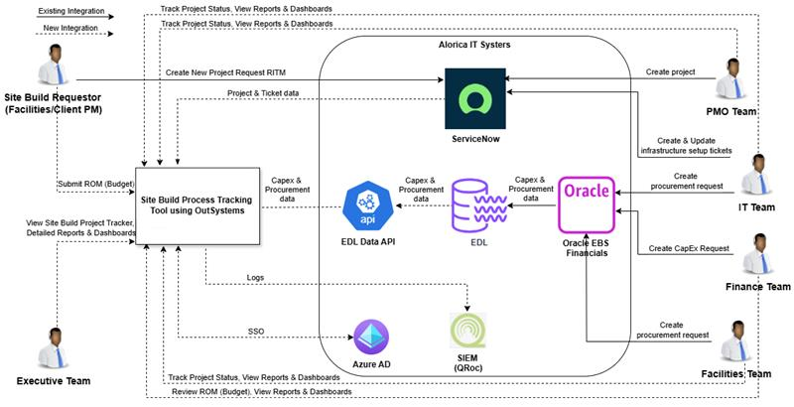
#Process Flow
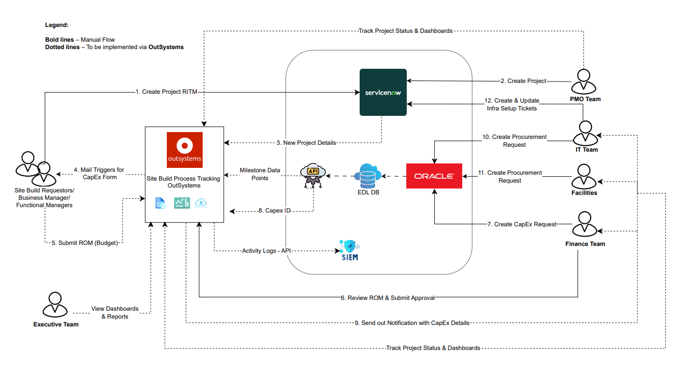
DETAILED TO BE PROCESS STEPS –
- Application Login
This application will be a web-based SSO (Single Sign-On) authenticated platform. Users will access the application via a secure login page, a sample of which is shown below -
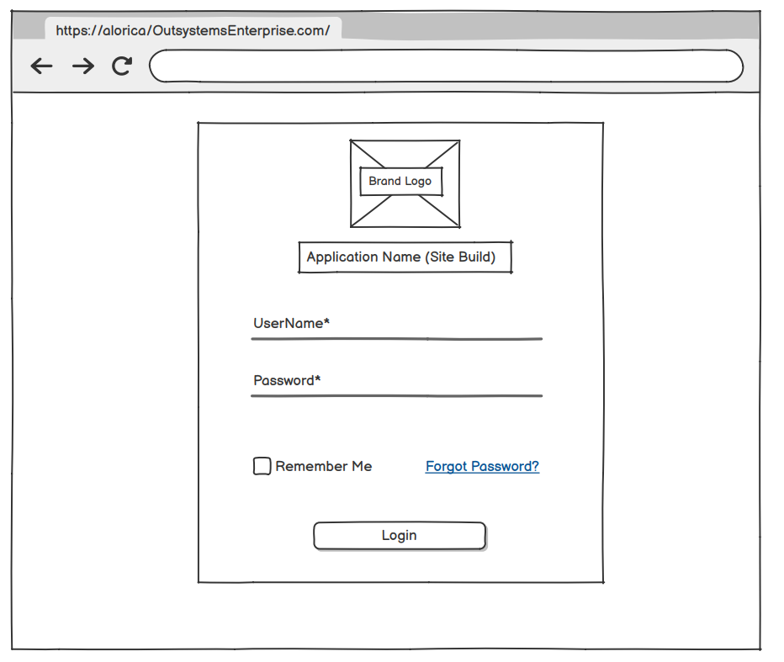
- New Project Dashboard
Whenever a new project request is submitted by the end user in ServiceNow, corresponding PRJ details will be auto-triggered to OutSystems platform through REST APIs.

ServiceNow API needs to be triggered twice –
1) When a new PJR is created for tracking category “Site Build” and initial state is “Pending” – This will be the Client Needs Identified
2) Second, when state is changed to “Work in Progress” – This will be Business Case Formulation

Once second trigger is received, OutSystems will auto-trigger the mail to business requestor and Business manager (Connie) with the link of form to auto-fill the details.
Hi [BR, BM],

Please note that we have received new project request for Site Build Process, PJR Number as “xx”.
Attached is the capex form link, please complete the next action items.

Thanks,
Site Build Process
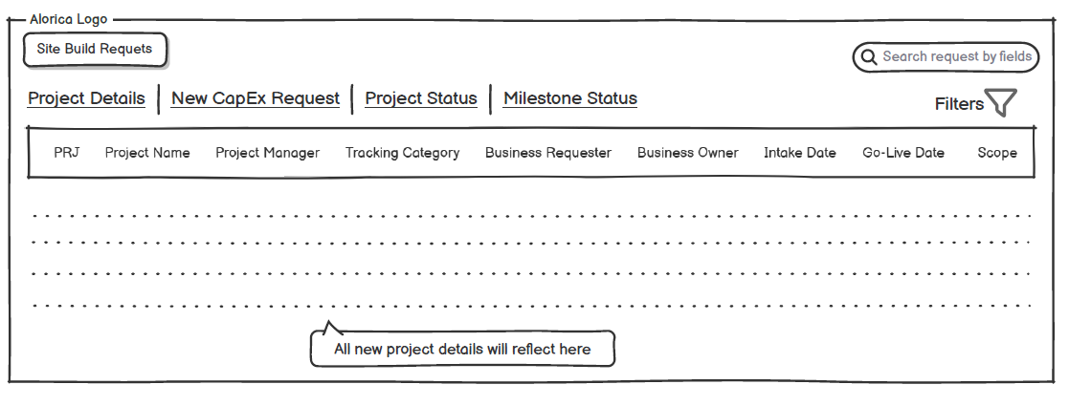
**State category needs to be included in this dashboard
Below are the parameters that will be covered in the to be form.

Category | Input Request Parameters | Output Response Parameters | Purpose | Source System
New Project details | PRJ Number | Response Body:  {"Status":"Success","Message":"The Data has been successfully submitted."} | Get Project data from Service now to start the site build approval flow. | Service Now  REST API
 | Project Name
 | Project Manager
 | Tracking Category,
 | Business Requester
 | Business Owner
 | Project Intake Gate (date),
 | Go-Live Date (date)
 | Scope
 | Region
 | State

- CAPEX FORM
Capex form will be replicated in OutSystems similar to the current one in power apps. Below are the steps that app follows for FORM submission –
- Once new PJR is received from (step1), mail will be auto-triggered to Business requestor and Connie to fill in the below sections of Capex form –
  - Requestor section – Most of the details will be auto-filled by the solution based on the data retrieved from ServiceNow. However, the fields will remain editable in case the requester or Connie needs to make any updates.
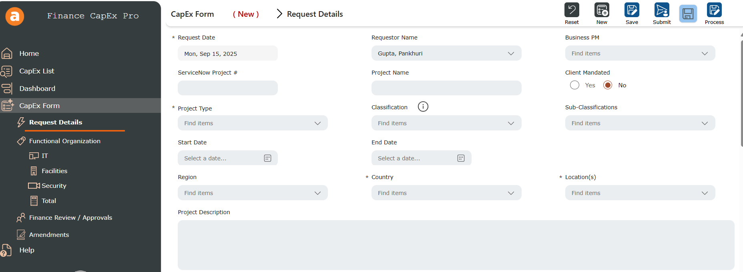
- Select Region - dropdown filter (EDL API)
Region North America
Region Asia
Region Latam
Corporate
Region EMEA
Region India
- Select Country - dropdown filter - it includes values as per the region selected. Values to be picked from EDL API
- Specific Location – Dropdown in to be form, values to be picked from EDL API
- CaPex Classification - dropdown filter - static values
- CaPex Sub-classification - dropdown filter - static values for each classification
CapEx Classification | CapEx Sub-Classifications
Growth | Growth
Maintenance | Capital Labor
 | Compliance
 | Critical Equipment
 | Infrastructure
 | LHI
 | Maintenance
 | Miscellaneous
Technology | Technology
 | Compliance
Relocation | Relocation

- Project Type - dropdown filter - static values will be integrated
New Logo
New LOB
Ramp Existing LOB
Seasonal Ramp
Site Build Expansion
Client Retention
Internal
Operations
Other

  - If Client Mandate is selected as YES, below fields need to be filled by Business requestor
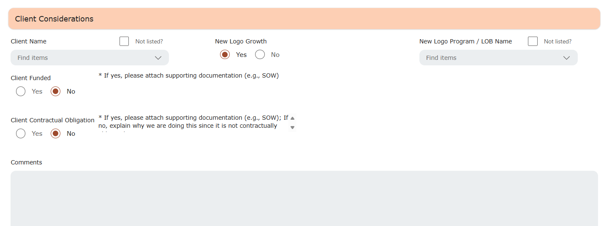
- Client Name – Dropdown in to be form – Details to be fetched from EDL API
- Client Funded – Dropdown – Yes/No
- Client Contractual Obligation – Dropdown – Yes/No
- New Logo Growth - – Dropdown – Yes/No
- New Logo Program/LOB Name – Text box /EDL API on availability

- Once Business Requestor save the request, mail will be auto triggered to Business PM to fill required functional leader details
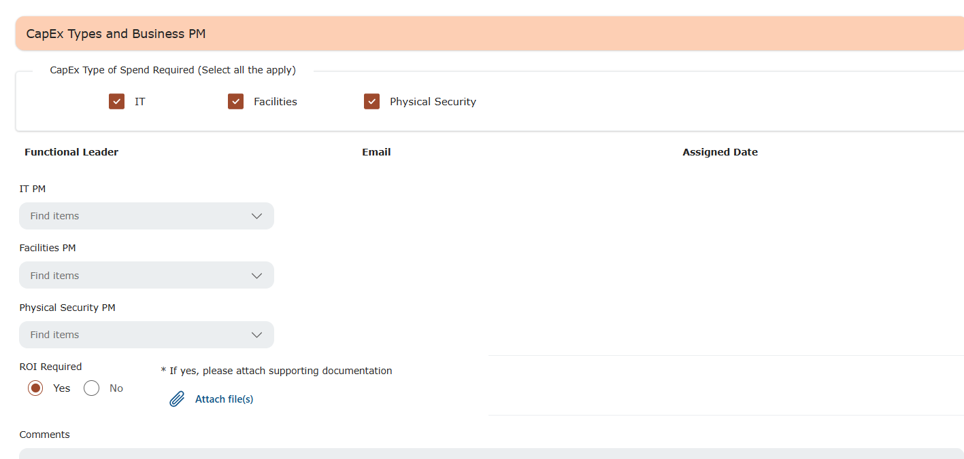
- CapEx Types of Spend Required – dropdown filter – Includes three static value – Facilities, IT, Security
- Corresponding functional leader to be selected – UserList from role management in OutSystems

Business Manager fill out the relevant details as shown above and will save the request, Mail will be auto-triggered to all functional manager as assigned with the link to access form.
- IT PM fill out the relevant details in the form as shown below-
  - IT Manager fill out the details, attach relevant snapshots and details in document summary and save it for further approval from IT Leaders.
  - Once they save it, notification mail will be auto-triggered to approvers.
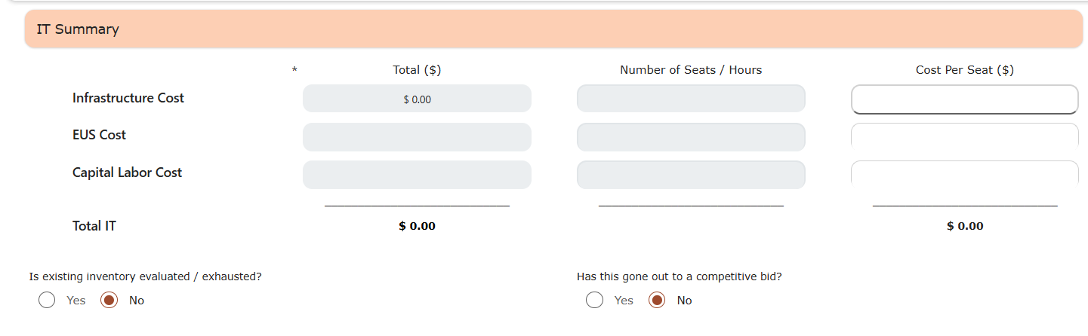
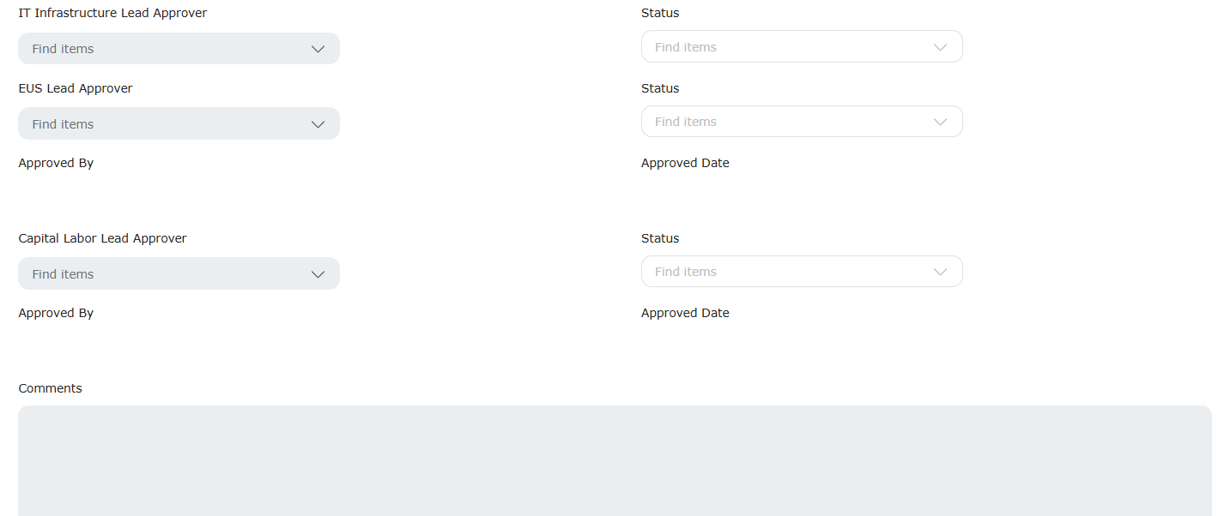
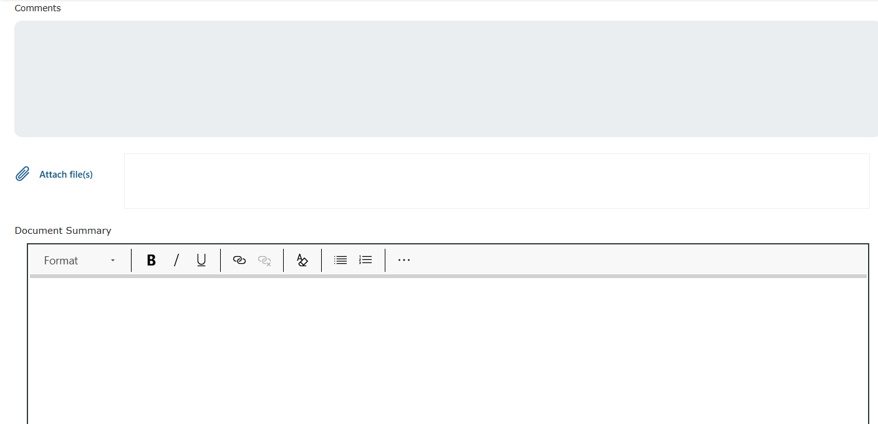

- Facilities PM fill out the relevant details in the form as shown below-
  - Facilities Manager fill out the details, attach relevant snapshots and details in document summary and save it for further approval from Leaders.
  - Once they save it, notification mail will be auto-triggered to leaders/approvers.
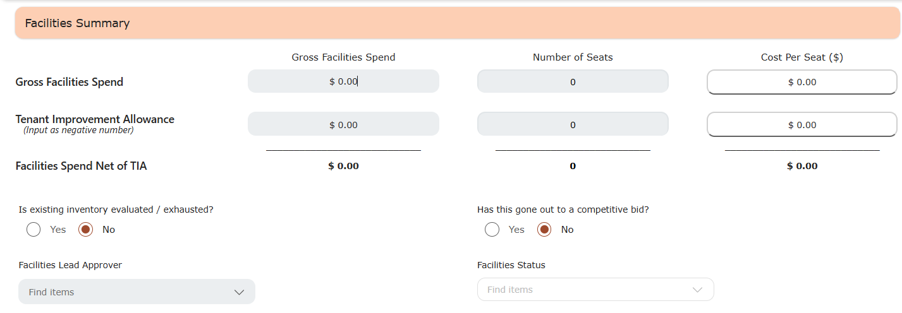
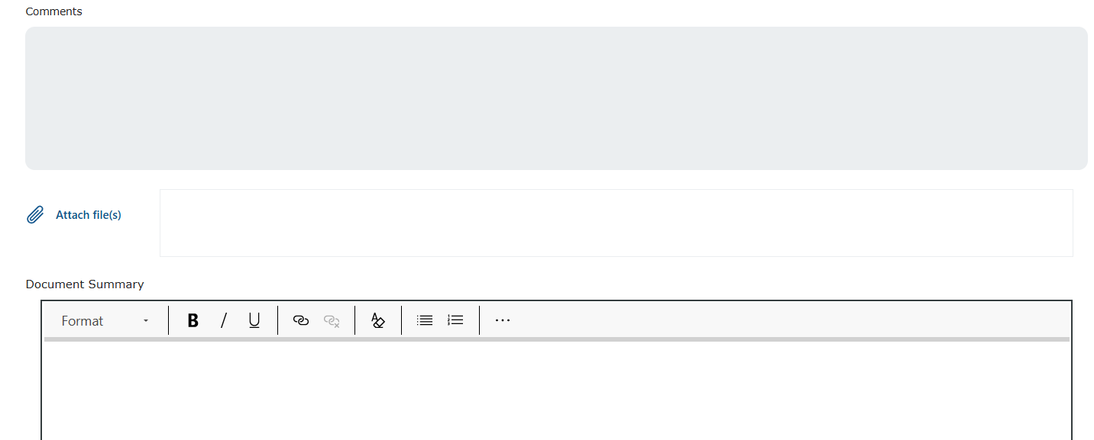

- Security PM fill out the relevant details in the form as shown below-
  - Security Manager fill out the details, attach relevant snapshots and details in document summary and save it for further approval from Leaders.
  - Once they save it, notification mail will be auto-triggered to leaders/approvers.
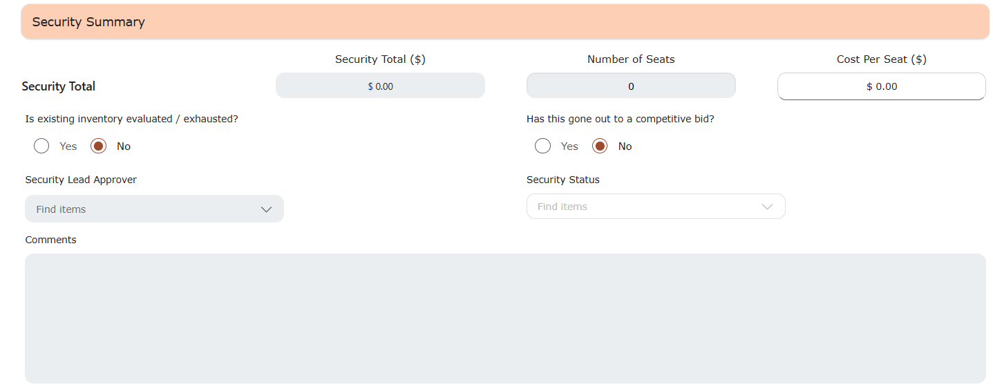
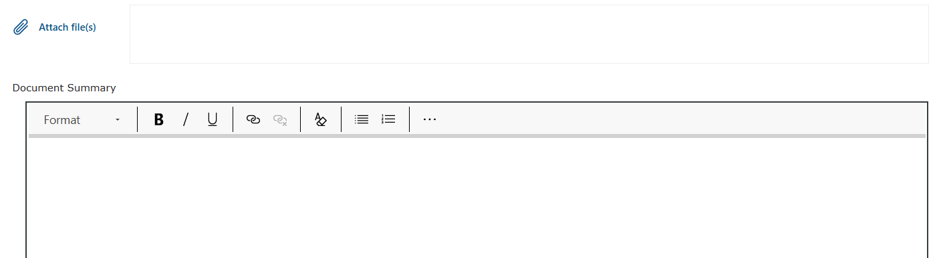
- Total of above filled details will reflect in the greyed-out section as below.
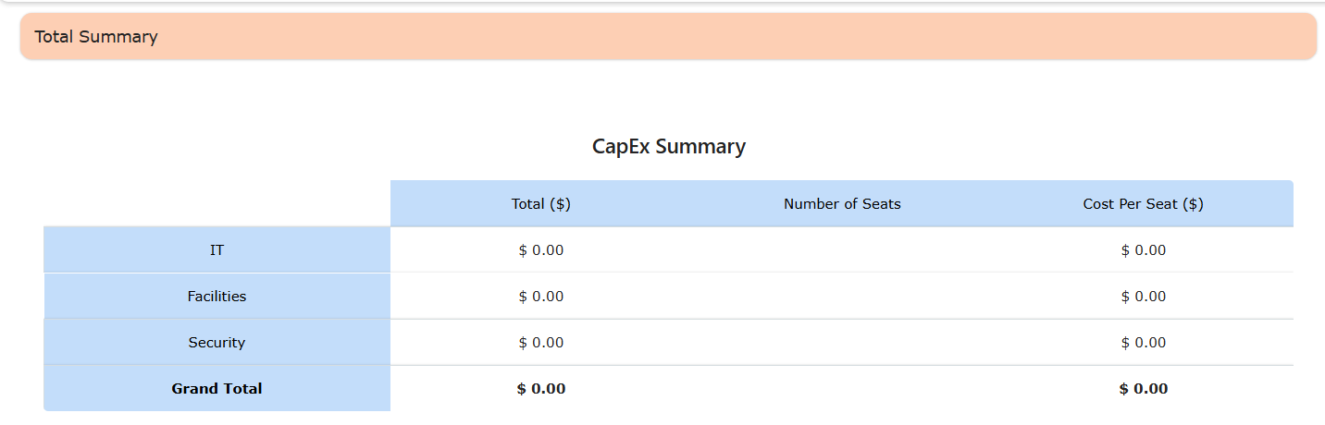

- Finance Approvals –
Once all the details are filled and submitted by all functional managers, mail will be auto-triggered (by OutSystems) to Business PM & Finance Team to initiate next steps.
Finance team will have consolidated view of all details captured over the form (snippets of update capex form attached for reference). They will assign Regional and VP approvers and save the request.
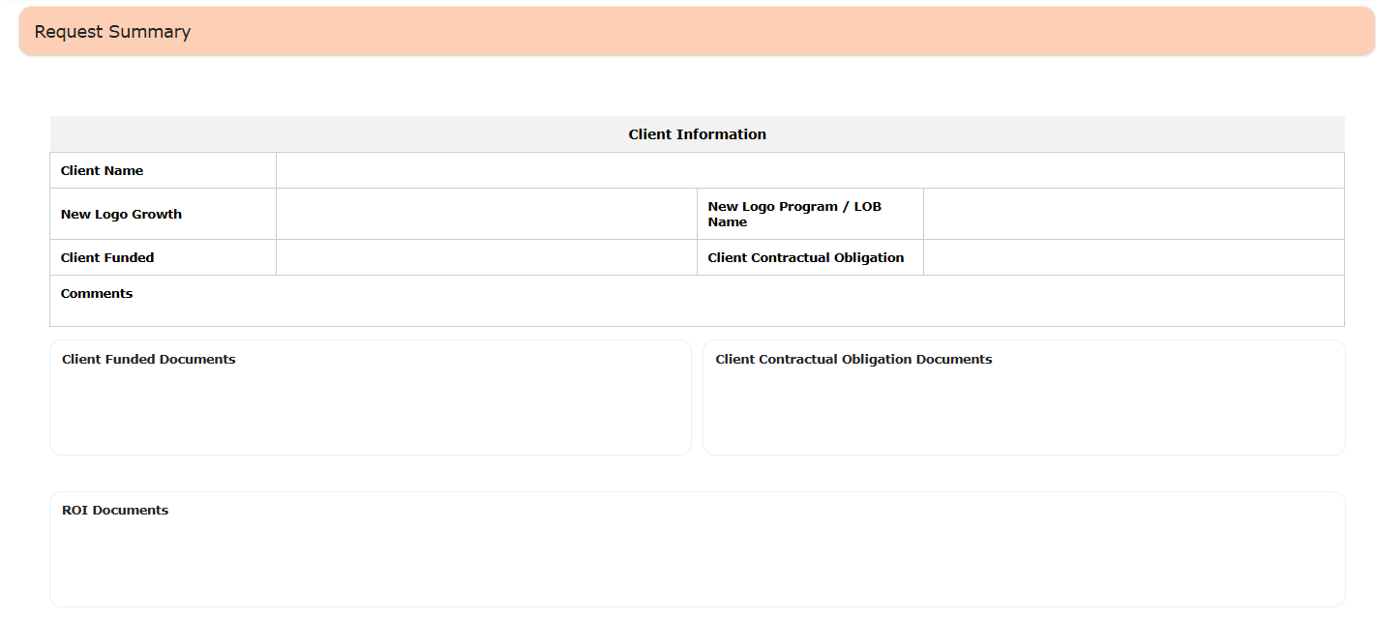
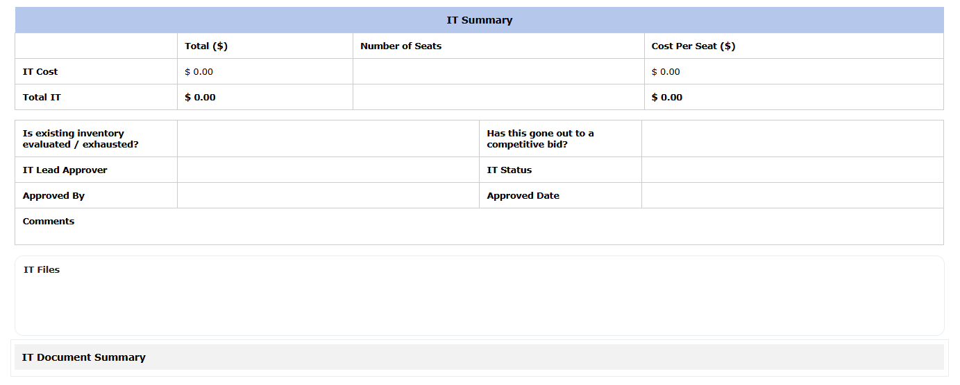
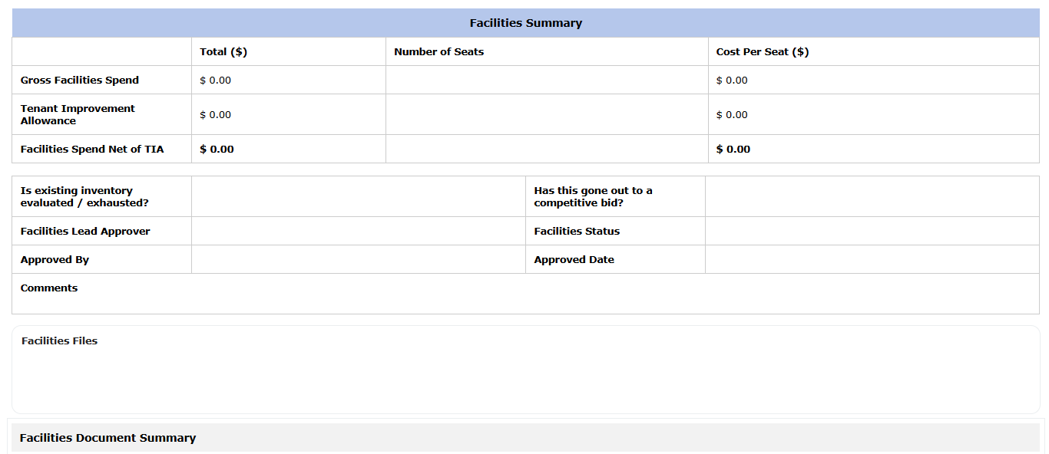
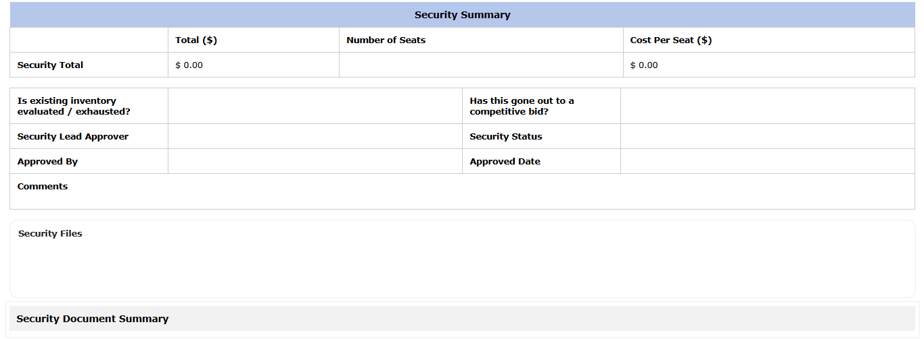
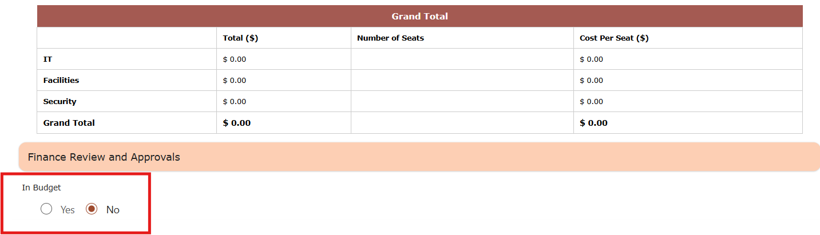

- Regional/Corporate Approver and VP Finance approver will get the notification through system that request has been submitted for there review and approval. Accordingly, they will access the application and submit their approval directly (snippets attached for reference)
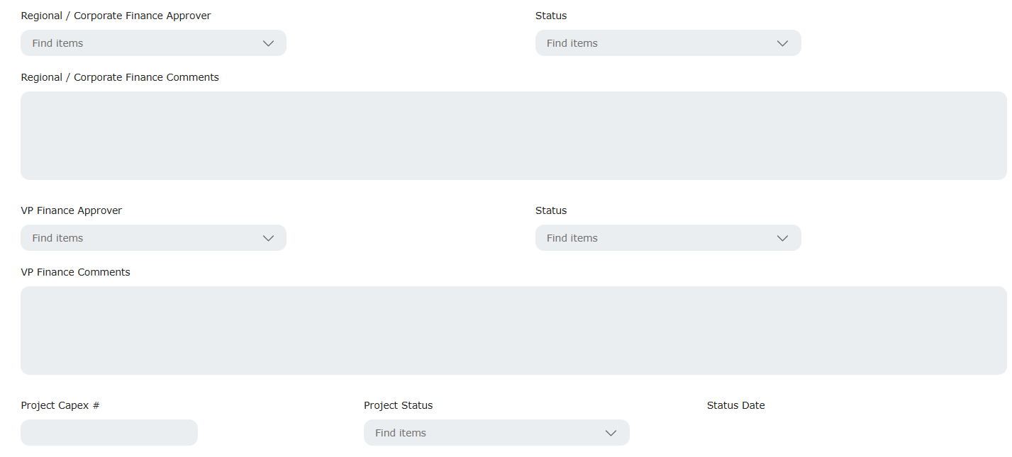
- The Finance team/Regional Approvers/VP Finance Approvers will have the ability to view and trigger emails to EC (Executive Committee) directly from within the application.
  - OutSystems will automatically generate the necessary snapshots and include the relevant files in the email body. However, the Finance team can review and make any necessary adjustments to the content before sending the email through the tool itself.
  - Two links to approve/reject will be included in mail.
  - Any response from EC over this mail needs to be tracked and needs to be stored over form and communicate to finance team.
- An additional approval section for Executive Committee needs to be added with below fields –
  - EC Approver – Dropdown (EDL API User List) – (Can be updated by EC or someone else on their behalf or needs to capture from Mail if responds received)
  - Status – Approved / Reject
  - EC Comments
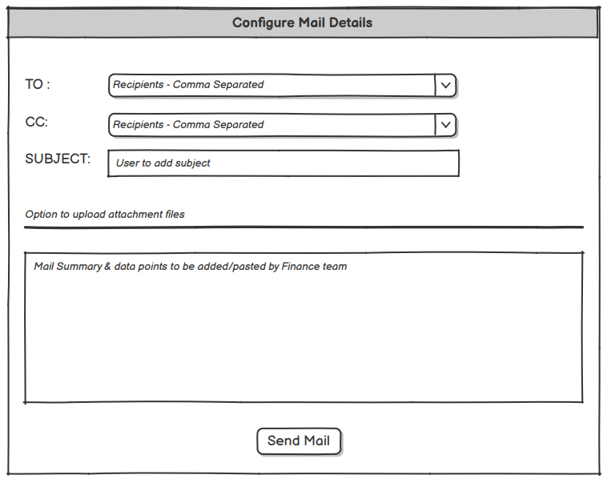

- Capex ID Generation Process (Manual Intervention)
The Finance team post all approvals upload all data to Oracle for generation of unique project related CAPEX ID. This Capex ID will be entered manually (or automatically updated) in OutSystems. Once the ID is entered, emails will be triggered automatically to all stake holders updating them that the project budget is approved and they can initiate the ordering process.
- CapEx Details – Capex number, status and date will be fetched by outsystem from EDL through API andthen project status will be submitted (If APIs are not available this step will be done manually by Business Manager/Finance Team)
One more field will be added to capture child-capex ids related to the corresponding processes (Users will have access to add the child capex IDs just for tracking reference)
- Amendment Section - To be Filled by relevant team in case of change in budget of already approved project.
  - Amendment Y/N – Dropdown filter – Yes/No
  - Amendment Amount (Incremental) – Numeric bar
  - Amendment Date – Calendar box
  - This request will be submitted using the Submit Project Status button
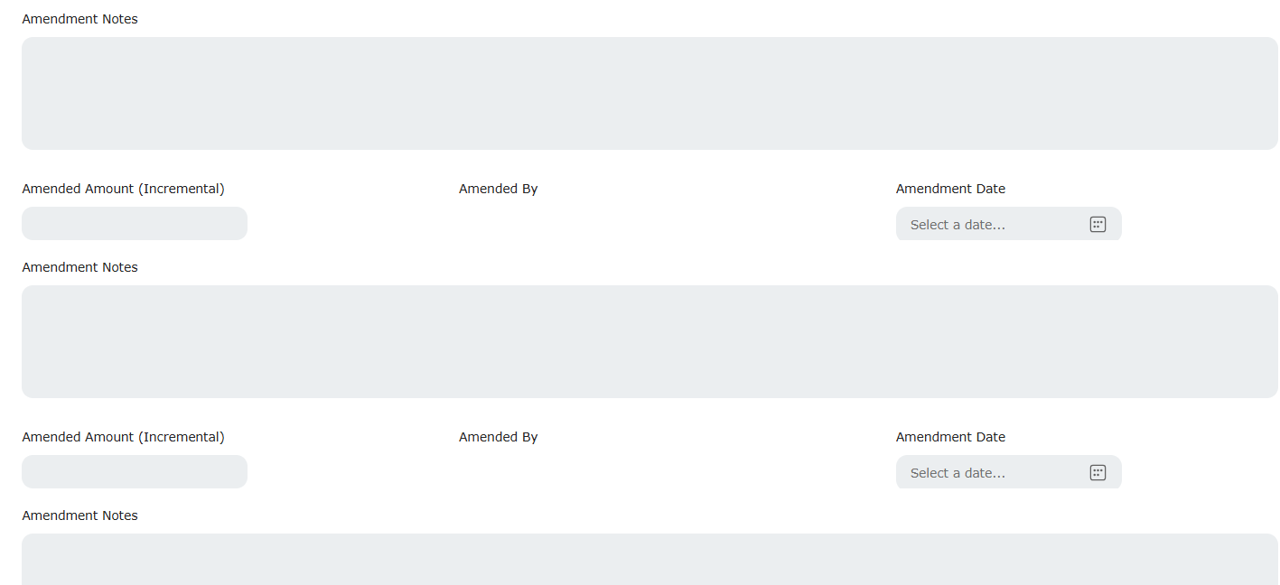
- SLAs will be tracked for each section of the Capex form, and automated email notifications will be sent to the Project Manager to ensure timely compliance.
- Once the Capex ID is generated –
  - Business manager will be notified to close the capex form.
  - Once the capex form is marked closed/submitted, automated emails will be triggered to all functional manager to initiate the next respective project-related activities.
- Facilities, IT Team, PMO teams’ activities related to procurement and project will be tracked in form of milestones as mention in step 3 below.
- Milestone Tracking
The solution will keep a track on key milestones across the project phases to ensure timely completion and compliance, Mails will be auto triggered in case of delays/Risks.
The data points for milestone tracking will be fetched through EDL APIs (Oracle) and ServiceNow APIs.
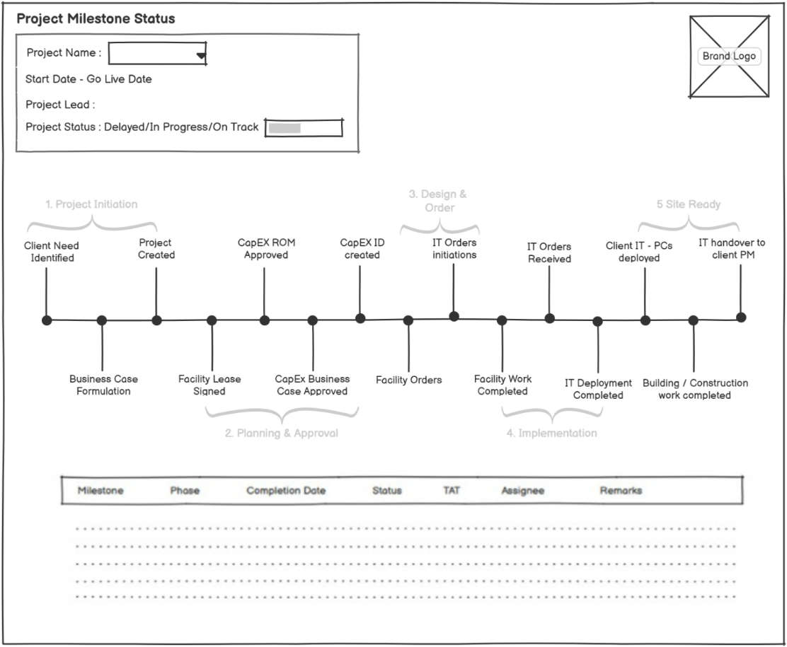
Below are the details of the milestones list and their respective sources-
Milestones should be marked as mandatory fields however there should be the option to select not applicable along with proper comments.
Phase 1 – Initiation
(*Data availability from ServiceNow through APIs)
Key Milestone | Input Parameters | Output Parameters | Source System
Client need identified | When State is pending | PRJ Number  Project Name  Project Manager  Tracking Category  Business Requester  Project Intake Gate (date)  Forecast Implementation/Nesting/Go-Live Date Scope  Region  State | Service Now  (REST API)
Business Case Formulation | When state is Work In progress

Phase 2 – Planning & Approval
Key Milestone | Input Parameters | Output Parameters | Source System | SLA
Facility – Lease Signed | PRJ Number | Signed Date | OutSystems | 15 business days from project creation
Sourcing Kickoff |  | Start Date |  | Facilities Team
Sourcing information received |  | Completion Date |  | Strategic Sourcing Team
CapEx ROM Approved
CAPEX form initiated | Details from OutSystems Form | Start date remains same for all. End date needs to be captured for each. | OutSystems | 3 business days after project creation by CapEx initiated
Capex / ROM Initiated & Approved - IT |  | Start date remains same for all. End date needs to be captured for each. |  | 7 business days after CAPEX form creation (includes 5 days to gather CAPEX data and 2 for Service Leader approval)
Capex / ROM Initiated & Approved - Facilities |  | Start date remains same for all. End date needs to be captured for each. |  | 7 business days after CAPEX form creation (includes 5 days to gather CAPEX data and 2 for Service Leader approval)
Capex / ROM Initiated & Approved - Security |  | Start date remains same for all. End date needs to be captured for each. |  | 7 business days after CAPEX form creation (includes 5 days to gather CAPEX data and 2 for Service Leader approval)
CapEx Business Case Approval |  | - |  | -
Business Case Approval submitted - Finance |  | Date |  | 2 business days after above 3 CAPEX details are entered
Business Case Approved - Executive Committee |  | Date |  | 5 business days after business case submitted to EC
CAPEX ID created
CAPEX ID created | PRJ Number, Project Requested date, Tracking Category | Capex ID, Status, Status date | EDL (Oracle)  (REST API) | 5 business days (need input from Leadership team on this
Selection Complete | PRJ Number | Completion Date | Field to be captured after CAPEX ID is created | 3 days from CapExId creation (Strategic Sourcing Team)

Phase 3 – Design & Order
Key Milestone | Input Parameters | Output Parameters | Source System | SLA
Facility Orders
Facility - Final Floor plans approved | CapEx ID, PRJ Number | Date | Facilities | 5 business days after CAPEX ID created  To be checked weather to include or not
Facility - Contractors / Orders for Build out given | CapEx ID, PRJ Number | Date, Status, Spent | Facilities | 10 business days after CAPEX ID Created
Facility - Critical Environments Systems Leased / Ordered | CapEx ID, PRJ Number | Date, Status, Spent |  | 10 business days after CAPEX ID Created
IT Orders Initiation
IT - Equipment orders placed (N/W, Server, WAPs, Firewalls) | CapEx ID, PRJ Number | Date, Status, Spent | IT Team | 7 business days after CAPEX ID Created
IT - Network link orders placed | CapEx ID, PRJ Number | Date, Status, Spent |  | 7 business days after CAPEX ID Created
IT - Security system orders placed | CapEx ID, PRJ Number | Date, Status, Spent |  | 7 business days after CAPEX ID Created
IT - PCs ordered | CapEx ID, PRJ Number | Date, Status, Spent |  | 7 business days after CAPEX ID Created
*Note - The above SLAs are applicable if orders are given to existing Vendors. These SLAs will change if we need to give orders to a NEW Vendor. In that case, the Vendor need to be onboarded first and then the orders are given out. Facilities to provide timelines for this case.

Phase 4 – Implementation/ Build Out
(*Data availability from OutSystems Form)
These milestones are currently maintained manually by different POCs. A form will be built in OutSystems to centralize this milestone tracking. Fields for Department Managers, Users (To be assigned by Manager for respective milestone), Add attachment options to upload site pictures wherever applicable, comment box for remarks will be added.

Key Milestone | Data fields required | Team / Department | Source System | SLA
Facility work completed
Building / Construction work started | date, pictures (Add attachments) / Paste link/descriptions in comment sections | Facilities | Facilities | 1 day after Orders are placed
Critical Environments | date, pictures (Add attachments if any), status, Comments | Facilities |  | 90 calendar days from construction start
Building / Construction work completed (Phase 1 / Phase 2 / Phase 3) | date, pictures (Add attachments if any), status, Comments | Facilities |  | 90 calendar days from construction start
Connected Utility | Date, status, comments, attachments (if any) | Facilities |  | 90 calendar days from construction start
IT Room (MDF / IDF) build out | Date, status, comments, attachments (if any) | Facilities |  | 90 calendar days from construction start.
IT orders received
IT - Equipment orders received (N/W, Server, WAPs, Firewalls) | Date, status, comments, attachments (if any) | IT / | IT Team | 90 calendar days from when IT Orders are placed
IT - Network link orders received | Date, status, comments, attachments (if any) | IT |  | 90 calendar days from when IT Orders are placed
IT - Security system orders received | Date, status, comments, attachments (if any) | IT |  | 90 calendar days from when IT Orders are placed
IT - PCs received | Date, status, comments, attachments (if any) | IT, Client PM, EUS |  | 90 calendar days from when IT Orders are placed
IT - deployment completed | Date, status, comments, attachments (if any) | IT |  | 30 calendar days after IT Room (MDF / IDF) build out completed

Phase 5 – Site Ready
(*Data availability from OutSystems Form)
These milestones will include the following details. Once all are approved, it will mark the closure of the current process and indicate that the site is ready.
These milestones are currently maintained manually by different POCs. A form will be built in OutSystems to centralize this milestone tracking. Fields for Department Managers, Users (To be assigned by Manager for respective milestone), Add attachment options to upload site pictures wherever applicable, comment box for remarks will be added
Key Milestone | Data fields required | Team / Department | Source System | SLA
Client IT - PCs deployed | Date, status, comments, attachments (if any) | Facilities | Facility Team | 1 day from IT - deployment completed
Building / Construction work completed - Production floor handover to Ops | Date, status, comments, attachments (if any) | Facilities |  | 90 calendar days from construction start
IT handover to Client PM | Date, status, comments, attachments (if any) | Facilities |  | 90 calendar days from construction start

- Project Status Dashboard
Using milestones data points and details extracted between Step 1 to Step 3, project dashboards will be maintained -
- Executive’s Dashboard – To monitor all project phases
Similar to the one shown as below, relevant pictures will be added depending on availability)
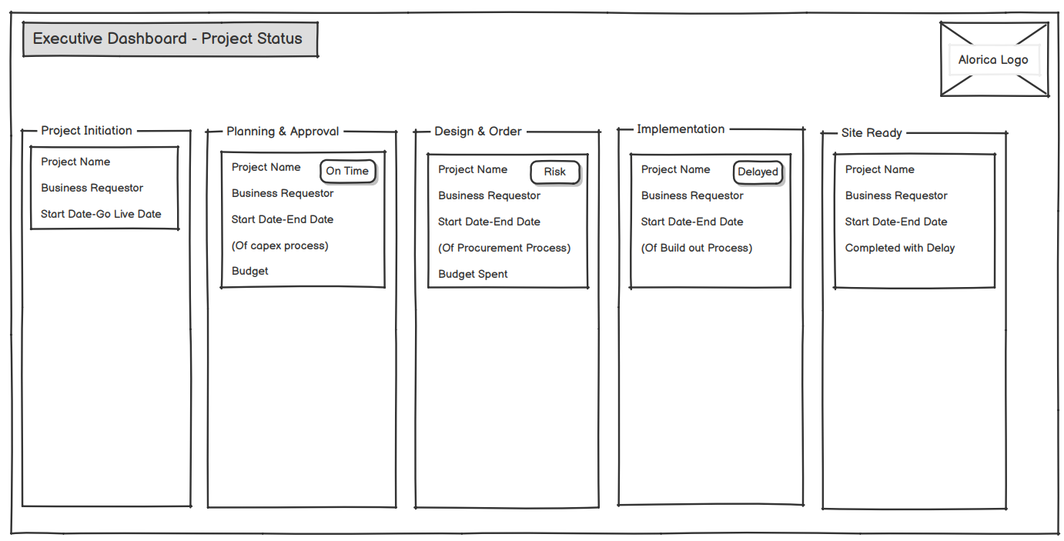
*Pls note – Relevant pictures, budget spent, and any additional details can be added to these dashboards depending on the availability of data points.
- Milestone Tracking – To track progress of selected project on milestone level
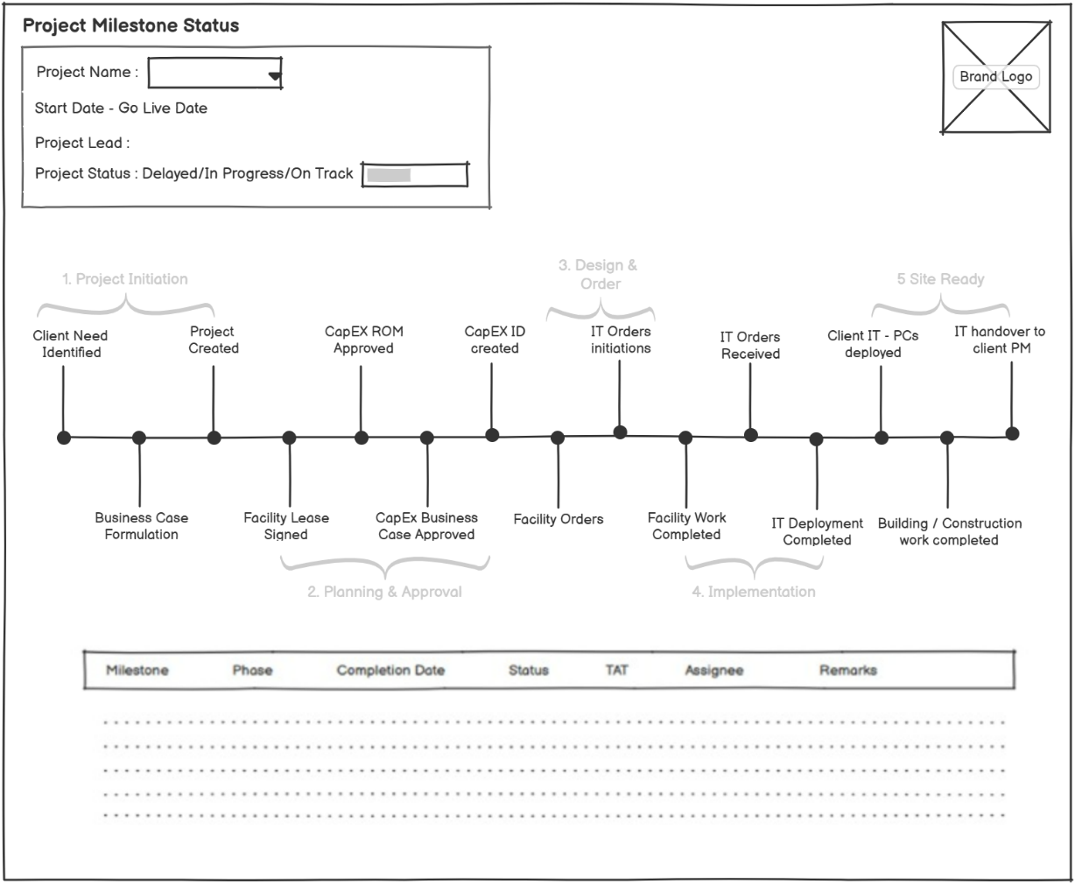

- Auditing Logs
To support real-time monitoring, logs from OutSystems will be integrated into Alorica’s SIEM platform
(IBM QRoc) via REST API. We’ll focus on key events like failed logins, role changes, deployment.
activities, and error spikes for security and operational visibility. Logging will be done using below fields
- Who performed the action (username, user ID)
- When the action occurred (timestamp, including time zone)
- Where the action originated from (IP address)
- What action was performed (event type, specific change)
- Why the action might have been taken (contextual information, if available)

4. Summary of data required via API
S.NO. | Category | Input Request Parameters | Output Response Parameters | Purpose | Source System
API -1 | New Project details | PRJ Number | {Status, Message} | Get Project data from Service now to start the site build approval flow. | Service Now  REST API
 |  | Project Name
 |  | Project Manager
 |  | Tracking Category,
 |  | Business Requester
 |  | Business Owner
 |  | Project Intake Gate (date),
 |  | Go-Live Date (date)
 |  | Scope
 |  | Region

S.NO. | Category | Request Parameters | Response Parameters | Purpose | Source System
API -1 | CapEx ID Created | PRJ Number, Project Requested date/Name, Tracking Category | Capex ID, Status, Status date | When the form approval is completed then we will need the CapEx Number from EDL. | EDL (Oracle)  REST API
API-2 | Facility - Contractors / Orders for Build out given | CapEx ID, PRJ Number | Date, Status, Spent | To Update Milestones after the approval of form So that the form can be updated
 | Facility - Critical Environments Systems Leased / Ordered | CapEx ID, PRJ Number | Date, Status, Spent
 | IT - Equipment orders placed (N/W, Server, WAPs, Firewalls) | CapEx ID, PRJ Number | Date, Status, Spent
 | IT - Network link orders placed | CapEx ID, PRJ Number | Date, Status, Spent
 | IT - Security system orders placed | CapEx ID, PRJ Number | Date, Status, Spent
 | IT - PCs ordered | CapEx ID, PRJ Number | Date, Status, Spent
API-3 | Power Apps Synchronization | Capex Form Data | Status | Sync OutSystems with Power Apps with all the forms getting approved in the OutSystems.
API-4 | AD User List | Get Request/NA | Alorica AD Users list  {Name, Email, EMP No.} | To select users to fill up and approve multiple sections of the form.
API-5 | Client Name List | Get Request/NA | List of client Names  {Name} | When Client mandate is true, we need to select Client Name from a list.  FYI: In current form it is a text (not a list)
API-6 | Site Location List | {Region,Country} | List of Site Location  {Location} | We need to select Site Location from a list.  FYI: In current form it is a text (not a list)

KEY ASSUMPTION
- The client would provide all the information/access (except for any commercials sensitive information) that is needed by Damco to successfully complete the project.
- Clients would initially help Damco in understanding the functional requirements and provide responses to any questions that Damco might have in the required phase.
- Damco cannot claim 100% accuracy, but we do claim to achieve 90%+ accuracy.
- The pricing is based on scope and assumptions mentioned in the proposal. Any new feature/ functionality will be considered as a change request.

